Brussels, 8th of July 2024
To Pierre BASCOU
Cc Antoine MICHOTTE RENIER

Dear Mr. Bascou,
FRUCOM represents and defends the interests of traders in dried fruit, edible nuts, peanuts, processed seafood and processed fruit & vegetables in the EU. We also work with the UK and the main origin countries (e.g. US, Turkey, Australia, Chile, among others).
We seek to facilitate the trade of safe and quality products in the EU and strive to ensure that our members are fully informed of the requirements imposed by EU legislation.
In this occasion, the new marketing standards regulation has given rise to several doubts about the correct interpretation, and we would like to take this opportunity to consult you on this regard. We have sought help from national authorities but did not always got consistent answers, so it is important to get information from the Commission for harmonisation in the EU market.
We would kindly ask for your clarifications on the following items:

- Scope of the regulation
Regulation (EU) 2023/2429 Art. 5, exemptions and derogations: which products are exactly meant by or covered by the following paragraph:
“(xvii) products classified as fruit and vegetables and listed in Part IX of Annex I to Regulation (EU) No 1308/2013 which have undergone a preparation going beyond the cutting specified in the applicable specific UNECE standard or which are not intact within the meaning of the general marketing standard, and which have been prepared for direct consumption in the fresh or cooked state”? Art. 5 1(b) xvii) is only referring to fresh cut vegetables and fruit, not dried (IV gamma products, French classification); based on feedback from the Commission to BMEL (German Ministry).
- Do chopped, sliced or ground nut kernels fall under the scope of Del. Reg. (EU) 2023/2429?
We understand that all nut kernels traded under CN codes 0802 xx xx do fall under the Reg. (EU) 2023/2429. This means blanched kernels (see description of the CN code 0802) and also chopped, sliced, broken pieces, but NOT milled (traded under CN code 1106 30 90 (flour, meal and powder of [...] or of products of Chapter 8).
- In our understanding, blanched almond kernels and other blanched nut kernels fall under the scope of Del. Reg. (EU) 2023/2429. Is that correct?
- In our understanding, salted or seasoned nut kernels do not fall under the scope of Del. Reg. (EU) 2023/2429. Is that correct?
- In our understanding, roasted nut kernels do not fall under the scope of Del. Reg. (EU) 2023/2429. Is that correct?
- In our understanding, sweetened or fried dried fruits do not fall under the scope Del. Reg. (EU) 2023/2429. Is that correct?
- In our understanding, the products with the following CN-Codes do not fall under the scope of Del. Reg. (EU) 2023/2429, is that correct?
  - 0804 30 00 10 – pineapples, dried.
  - 0804 50 – guavas, mangoes and mangosteens.
  - 0813 50 31 – specific mixtures of dried fruit.
  - 0813 50 39 – specific mixtures of dried fruit.
To our knowledge, the marketing standards are not applicable; Reg. (EU) No. 1308/2013, Annex I, Part X: ex 0813: Fruit, dried, other than that of headings 0801 to 0806; mixtures of nuts or dried fruits of this chapter excluding mixtures exclusively of nuts of headings 0801 and 0802 falling within subheadings 0813 50 31 and 0813 50 39; The German competent authority "BLE" has confirmed that origin labelling is not necessary.
What does the term “product” in the regulation refer to?
- The consumer sales units sold in retail outlets to end consumers?
- Packages containing these consumer sales units?
- Packages of bulk raw materials?
- And what about mixed 'products' (a mixture of nuts and sultanas, for example)?
For some products we are wondering whether they are in the market without having undergone preparation. For example, dried plantain, dried pineapple, dried avocado, dried guava, dried mango and dried mangosteen. These products seem to be most commonly found sliced or diced, instead of whole. Are these products exempted because they do fall under article 5 xvii at all times "always prepared beyond the extend of trimming"?
Does the mandatory indication of origin according to Del. Reg. (EU) 2023/2429 trigger the obligation for origin labelling according to Reg. (EU) No 1169/2011 on provision of food information to consumers – Art. 26(3)?
Are sample consignments sent to companies for laboratory purposes or for sensory testing subject to origin labelling or are there exemptions? If so, where are they described?

- Determination the origin
By “country of origin”, in accordance with Article 1(3) of Regulation 2023/2429, the country of origin of a product should be determined in accordance with Article 60 of Regulation (EU) No 952/2013. For example, if a hazelnut is grown in Turkey and shelled in Italy, the origin would be Italy. Could you please confirm this assessment?
In our understanding, in accordance with the article 8, the origin will be the place of transformation. Is it then the responsibility of the operator to provide the origin?
When determining the country of origin, are customs agreements from trade agreements taken into account or is the “country of origin” determined strictly and only in accordance with Art. 60 Reg. (EU) No. 952/2013 (as mentioned in Del. Reg. (EU) 2023/2429 Art. 1(3))?

- Labelling of mixtures (Del. Reg. (EU) 2023/2429 Art. 8)
In product specifications of nuts in retail it is customary to mention a selection of countries of origin as possible origins of the goods. In the case of hazelnut kernels, for example, Turkey, Georgia and Italy are known origins for high-quality goods. Depending on the availability and purchase prices, the batches are mixed before packing, resulting in different combinations of countries of origin. See example below:
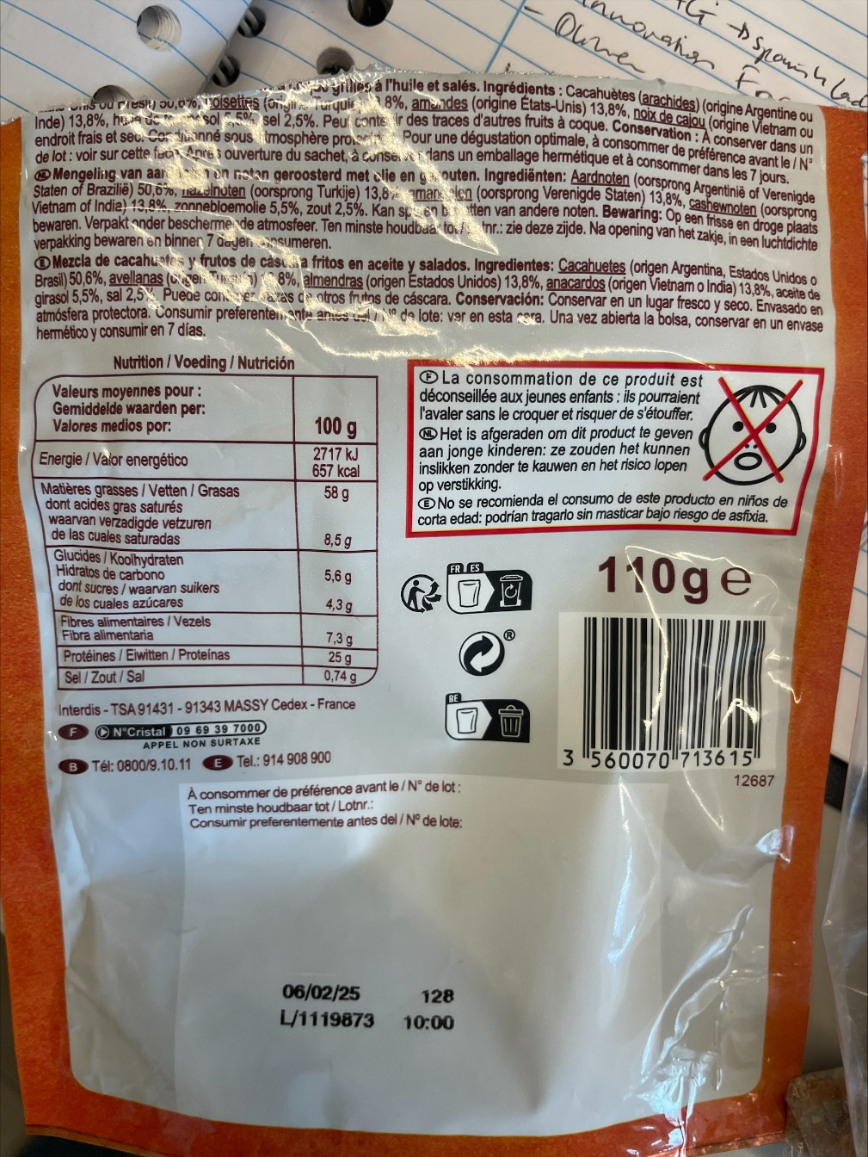
Is it possible to use terms such as "to guarantee year-round supply, this product can come from COUNTRY 1 or COUNTRY 2”?
It is not clear whether the Regulation also prohibits marketing of different origins of the same product in one packet, provided the origin information is given e.g. “product of countries X, Y and Z, in varying quantities” (e.g. Turkey, Georgia and Italy). Could you please provide clarification on this subject?
Delegated Regulation (EU) 2023/2429 does not apply a specific marketing standard or a general marketing standard for nuts, as it does for some other fruits and vegetables. In the case of most fruits and vegetables, the product must come from the same origin. For example, the specific marketing standard for oranges states:
“The contents of each package must be uniform and contain only citrus fruit of the same origin, variety or commercial type, quality and size, and appreciably of the same degree of ripeness and development.”
There is also the exception of Article 8.2.
Would it be possible to receive clarifications on these subjects?
The origin labelling of mixtures concerns dried fruit mixtures, nut kernel mixtures and dried fruit-nut kernel mixtures. Mixtures of nuts in shell should be considered separately, as nuts in shell fall under the general EU marketing standards.
There are several varieties of the above mentioned mixtures.
Are the following labelling schemes correct?
- Mixtures of nut kernels and/or dried fruit, all of which are covered by mandatory origin labelling.
(Example: trail mix made from hazelnut kernels, almond kernels and sultanas)
Labelling: "Origin: EU", "Origin: non-EU" or "Origin: EU and non-EU". Correct?
- mixtures of nut kernels and/or dried fruit covered by compulsory origin labelling and nut kernels and/or dried fruit not covered.
(Example: trail mix made from hazelnut kernels, almond kernels, sultanas and cashew nuts)
Labelling: "Origin: EU", "Origin: non-EU" or "Origin: EU and non-EU". Correct?
- mixtures of nut kernels and/or dried fruit covered by compulsory origin labelling and other products.
(Examples:
a. Student food made from hazelnut kernels*, almond kernels*, sultanas* and peanuts;
b. Trail mix made from hazelnut kernels*, almond kernels*, sultanas* and sweetened cranberries;
c. trail mix made from hazelnut kernels*, almond kernels*, sultanas* and chocolate chips;
Labelling: "*Origin: "EU", "*Origin: non-EU" or "*Origin: EU and non-EU". Correct?
- Mixtures of oilseeds with a small proportion of nut kernels that are subject to mandatory origin labelling:
(Example: seed mixture with sunflower seeds, pumpkin seeds and a small quantity of pine nuts)
No origin labelling required. Correct?
Optional: seed mix with sunflower seeds, pumpkin seeds and a small amount of pine nuts*: "*Origin: "EU" or "*Origin: Non-EU. Correct?

- Transitional period
Is there any transition period for using existing labels/packaging produced before 1st Jan 2025 to avoid food waste and waste of packaging material?
Below you may find some examples of technical issues experienced by our members:
1. the origins of the raw materials that are packed in a particular pre-package change in some cases per batch or at least frequently (e.g. almond kernels from Australia, the USA and Chile) or are even mixed before filling in order to achieve a certain sorting in terms of size that is desired by the trade. The availability of goods also plays an important role.
2. In practice, this means that the country of origin must be printed together with the best-before date and other constantly changing information such as lot numbers etc. using inkjet or thermal transfer printing directly during filling.
3. In practice, small free spaces are left on the packaging for this purpose, which can be printed during filling (see example below).
4. In order to have enough space for the additional print, packaging materials (usually films) must be adapted (lead time with use of existing materials, graphic adaptation and reprinting - required period: approx. 24 months).
5. Companies have to make considerable investments in the pre-press stage in addition to the costs for the graphic adaption of the films. Investments must be made in printing cylinders with which the foils are printed. The cost per cylinder is around 500 to 2000 euros per colour, depending on the print area or width of the cylinder and the printing process. It is usually printed with 5 to 8 colours, whereby several colour cylinders or all colour cylinders have to be changed during revision. Digital printing is no alternative when printing large quantities of film. Numerous products are affected. For a medium-sized brand manufacturer or packer, the estimated investment is around 100,000 euros.
6. Companies may also need to invest in new printers that can print larger areas.
7. The transfer of origin information in the supply chain must also be mapped - with batch accuracy from the origin to the packaging machine.
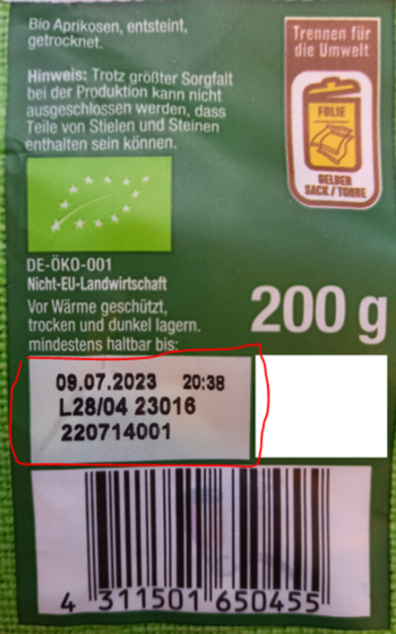
8. The printing quality and its negative impact may be an issue, because authorities may complain that it does not comply with the general labelling rules on the size of characters. For large volumes of pre-printed labels, companies must anticipate changes of sourcing, and these considerations may represent limiting factors to business decisions.

- Labelling on the end consumer packaging and on bulk goods in B2B business
Is it possible to use the internationally standardised ISO codes for labelling the countries of origin?
Is it correct that for dried fruit and nuts covered by Regulation (EU) 2023/2429, the country of origin MUST be labelled on the transport container (carton, bag, big bag, etc.) on bulk goods? Is it correct that the name and home address of the packer and/or sender (e.g. street/city/region/postcode and - if not identical to the country of origin - country) must be indicated on the transport container?

Thank you for your attention.

Sincerely yours,

Anna Boulova

FRUCOM Secretary General

