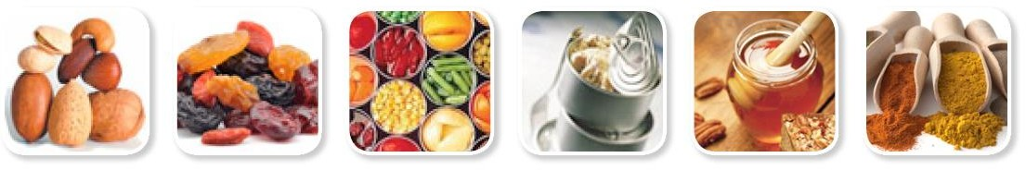

FRUCOM JOINT WORKING GROUPS
PROCESSED FRUIT & VEGETABLES / PROCESSED FISHERY PRODUCTS
16 March 2026
15.00-16.30 CET (Brussels) time
Microsoft Teams: https://teams.microsoft.com/meet/36122469424674?p=hptmTod1quwh35oLVk
Meeting: 361 224 694 246 74
Code: jS7gv2UA

AGENDA

Agenda items | Speakers
- Approval of draft agenda and report of previous meeting

Discussion with DG MARE -
Trade with Third countries  - Trade preferences and Free Trade Agreements e.g., Indonesia, the Philippines, India, Thailand  - The US – state of play  - ATQs – state of play, requirements of sustainability?  - Morocco – state of play after the adaptation in 2025 of bilateral trade provisions  - Russia – state of play  - GSP revision and GSP+ timeline  CATCH implementation, Q&A  - • Time required for the operators to fill in the information – facilitating the process?  - • Action to correct possible errors in the certificates  - • Flexibility granted by some MMSS and future outlook | 15.00-15.40  MALINOWSKA-FACCI Kinga,  SZATKOWSKI Pawel,  Unit B.3 Trade Negotiations and Sustainable Fisheries Partnership Agreements  15.40-16.05  Pavlina NIKOLOVA,  Unit B.4 Illegal, Unreported and Unregulated Fisheries Policy
Food safety and sustainability issues
- Packaging and packaging waste update for canned goods  - Anti-dumping canned sweet corn, canned mandarins.  - Guidance on forced labour  - Traceability for seafood  - Contaminants (mineral oil, inorganic arsenic, PAH, PFAS, heavy metals mercury).  - Antimicrobials – Requirements entering into application on 3 September 2026.  - Additives (SO2).  - BPA.  - List of approved countries for imports of aquaculture products.  Nutrition and communication activities | FRUCOM secretariat, Lebo Mofolo/ João Pereira/Martina Zurli

PAGE 2 / 2

