**FRUCOM Manifesto**

**2024**

**-**

**2029**

**Who we are**

FRUCOM represents and defends the interests of traders in dried fruit, edible nuts, peanuts, processed seafood and processed fruit & vegetables in the EU. We also work with the UK and the main origin countries (e.g. US, Türkiye, Australia, Chile, among others).

FRUCOM seeks to facilitate the trade of safe and high-quality products in the EU and ensure that its members are fully informed of the legal requirements. Based in Brussels, it is a platform promoting fruitful interactions between its members, while representing them to the European institutions.

FRUCOM contributes to the visibility of the sector and to a favourable trading environment in the EU. FRUCOM engages with the European institutions on relevant topics through official channels, defending the priorities and interests of its members.

**Commitments:**

* Full compliance with the European legislation, namely on food safety and sustainability.
* Provision of high-quality products meeting the demands of the consumers.
* Where relevant, development and implementation of voluntary commitments and good practices (e.g. pre-export checks on almonds, pistachios and peanuts).
* Where relevant, compliance with third party standards (such as the BRC, UTZ Certified, ECO Cert, Fair Labour Association, the Business Social Compliance Initiative, etc.).

**FRUCOM’s Role**

* Fostering cooperation between its members on common issues, strengthening the sector as a whole.
* Creating positive synergies among its members – the support to healthy food has positive repercussions in other areas, such as reduced costs to health systems.
* Connecting the sector and the EU institutions.
* Delivering industry expertise to EU discussions and positively influencing EU legislation through official channels.
* Supporting access for third countries to the EU market.

**Our Products**

**FRUCOM products commercialised in the EU are largely dependent on imports**

Imported food products are a fundamental part of the EU citizen’s diet, filling in the gaps where EU production cannot satisfy the demands of consumers. Some examples include:

Dried nuts such as peanuts, cashews, pecans, macadamias and Brazil nuts are not produced in the EU and are entirely imported from third countries.

On almonds, the EU imported over 250.000 tonnes from the US alone in 2023 (which produces over 80% of the world’s almonds). Spain is the second largest producer, totalling 6%. Dates are not produced in the EU, and Tunisia is the largest supplier, totalling 60.000 tonnes in the past year.

On pistachios, the US, Iran and Türkiye represent 97% of the world’s production. The EU producers, combined, amount to less than 1%. The EU imported over 80.000 tonnes from the US alone in 2023.

Costa Rica is the main source of pineapples supplied to the EU. It represented 88% of total imports in 2023, accounting for 685.000 tonnes.

The EU has an overall import reliance of 67% for seafood, with an estimated EU supply of 3.2 million tonnes and import of 8.9 million tonnes.

The vast majority of shrimp consumed in the EU is imported (99% import dependency), while the situation is similar for tuna (import dependency of 94%). Ecuador is a key partner to the EU, representing 24% of the imports of tuna and 22% of shrimp.

The EU is largely dependent on imports from sardines, importing 91% of its consumption from Morocco.

Sources:

Access2Market (2022 and 2023, EU27).

EU Seafood market: AIPCE – CEP FinFish study.

**Main FRUCOM strategy pillars:**

1. Food Safety
2. Nutrition
3. Sustainability

**Asks to policymakers:**

* Level playing field.
* Less and clear legislation with sufficient transition time.
* Support for sustainable, healthy and nutritious foods and for “positive nutrition”.

Level playing field: securing free trade is the key strategic goal for a reliable food system in the EU

Imports are a necessity and play a crucial role to fill in the gaps of products which cannot be produced in the EU. Our companies need free access to their target markets, as well as secure global sourcing. To achieve this, compliance with and implementation of all requirements must be actively supported. Only then it is possible to compete at high quality level.

Less and higher quality legislation structured in a proportionate and harmonised manner

The EU farming and EU food system are linked to trade. FRUCOM favours less and higher quality legislation, which is focused on the needs, prioritises business value added, is proportionate and harmonised. When legislation changes, sufficient transition time is a necessity. Furthermore, subjects like import control regulations and mineral oil levels are not addressed in an equal manner across all the EU member states, creating barriers which hinder the flow of trade.

FRUCOM products contribute to sustainable nutrition within planetary boundaries

Products such as dried fruits, nuts and peanuts are generally responsible for far fewer greenhouse gas emissions per kilogram of food compared to other agricultural products such as beef, dairy and poultry. Moreover, they are nutrient dense, thus they provide substantial amounts of valuable nutrients, improving diet quality. EU authorities need to support their positive contribution on this regard, focusing on the promotion of the increase of these nutrients in diets.

**Pillar 1 – Food Safety**

**Asks to policymakers:**

* Ease administrative burden in agri-food trade with better, targeted support to the implementation of regulations.
* Achieve a longer transition time in case of regulation changes.
* Harmonised legislation applicable at the EU level (e.g. MOSH, import control regulations).
* Statistics/data-based approach to legislation (e.g. on official controls).
* A solution-oriented EU pesticides policy, with more involvement by operators.
* Creation of an EU Organics framework to improve organic trade.

FRUCOM monitors multiple official channels and reports on food safety and food law subjects, including import controls, food additives, contaminants, RASFF notifications, audits in third countries linked to food safety, etc.

FRUCOM actively engages with members and partners to support members on full compliance, in platforms such as the FRUCOM Dried Fruit, Peanuts and Nuts working group, as well as the Processed Fruit, Vegetables and Seafood working group.

FRUCOM participates in EU-led initiatives and working groups, representing its members in relevant discussions such as the Civil Dialogue Group on Organic Farming, MAC (Market Advisory Council of Fisheries and Aquaculture) and LDAC (Long Distance Fisheries Advisory Council).

FRUCOM manages a pesticides and contaminants data collection project: a comprehensive and up-to-date database of relevant residues in the nuts and dried fruits sector, as a risk-management tool.

**Pillar 2 – Nutrition**

FRUCOM wants to drive the consumption of healthy foods to fill the gap between academia and consumers. Influencing nutritious food choices by connecting the science of nutrition with the science of behaviour change leads to a concrete change in consumer choices.

**Asks to policymakers:**

* FRUCOM products contribute to sustainable nutrition within planetary boundaries and should be prioritized in the EU policies.
* Support positive nutrition. For example, focus on encouraging the consumption of healthy nutritious foods containing specific nutrients (vitamins and minerals, unsaturated fatty acids...) which have a positive impact on the diet quality, in place of increasingly imposing restrictions on nutrient quantities.

**Nutrition and Communication Working Group – Milestones:**

Group objectives:

* Focusing on the added value of the products
* Promoting a positive image of the products among experts, food policy makers as well as consumers
* Work on the nutrition policy
* Answer to questions about nutrition from the members
* Prepare useful communication material for members and social media

Group deliverables:

* Contribution to FRUCOM replies to public consultation
* Contribution to FRUCOM position papers, articles, communication material.

Areas of interest:

* Divulgation of scientific research in relation to FRUCOM products
* Communication to policy makers/associations/potential members/consumers
* Policy developments (health/nutrition claims, labelling)

**Benefits and Advantages of FRUCOM products – Did you know?**

Unhealthy diets are a major contributor to the global burden of disease. Globally, diets low in fruit, vegetables, nuts and seeds are risk factors for morbidity and mortality, specifically for cardiovascular diseases. Nuts and seeds, fruit, fibre and omega-3 fatty acids intakes are below the optimal level.

FRUCOM products are a pivotal part of healthy dietary patterns, through helping meeting the nutrient requirements and therefore contributing to diet adequacy.

Fish contains Omega 3 (EPA/DHA) which contributes to the normal function of the heart?

Walnuts contribute to the improvement of the elasticity of blood vessels and are high in omega-3?

Prunes contribute to normal bowel function and are high in fibre?

A single Brazil nut contains almost double the daily reference intake for selenium?

Hazelnuts, Figs and Dates are high in fibre?

Dried apricots, dates and raisins are high in potassium?

Canned mandarins are high in Vitamin C, while canned tomatoes are a source of Vitamin C?

Almonds are high in Vitamin E, which contributes to the protection of cells from oxidative stress?

Sources:

Health effects of dietary risks in 195 countries, 1990–2017: a systematic analysis for the Global Burden of Disease Study 2017 - The Lancet

<https://www.thelancet.com/article/S0140-6736(19)30041-8/fulltext>

**Pillar 3 – Sustainability**

**Asks to policymakers:**

* Less and better legislation in consultation with businesses.
* Recognise private sustainability initiatives.
* Focus on practical implementation – provide informative resources, such as “how to” guides and more databases, integrate these into existing platforms.

FRUCOM organises the Sustainability Working Group with its members and stakeholders to foster cooperation on sustainability.

**Examples of sustainable practices in the production of FRUCOM products:**

Edible nuts and seeds:

Walnuts – US producers employ Research and innovations for a more sustainable production: adapted irrigation methods, less pesticides and reduced vehicle and equipment emissions.

Almonds – Producers use a “whole-orchard” approach, where wood chips are used for soil enrichment and almond by-products are used for feed, biofuels, sugar and sweetener production. More than 80% of producers use micro sprinklers or drip irrigation systems to lower water consumption.

Dried fruits and vegetables:

Raisins – Producers in South Africa use byproducts to raise cattle: the water from cleaning raisins is used for irrigation and grape waste becomes animal feed.

Processed fruits and vegetables:

Peppers – Producers in Türkiye combat the increasing water scarcity by installing drip irrigation systems.

Pineapples – Producers in Kenya enforce policies against coerced and child labour. They ensure a safe work environment, while contributing to the prosperity of local communities.

Processed fish and seafood:

Shrimp – the Sustainable Shrimp Partnership aims at increasing the environmental and social performance of farmers in Ecuador. It requires that all members are Aquaculture Stewardship Council (ASC) certified, use zero antibiotics, that products are fully traceable and have minimal environmental impact.

**FRUCOM position papers and responses to public consultations:**

* Forced labour product ban.
* Packaging and Packaging waste regulation disposal.
* Sustainability due diligence directive proposal.
* Reciprocity of EU standards on agri-food imports.
* Supply chain due diligence.
* Product environmental footprint.
* Proposed sustainable EU food system.
* Green claims directive.

FRUCOM is a founding member of the EU Agri-food chain sustainability roundtable, which brings together European agri-food chain industry associations whose activities are impacted by the European legislative framework related to sustainability.

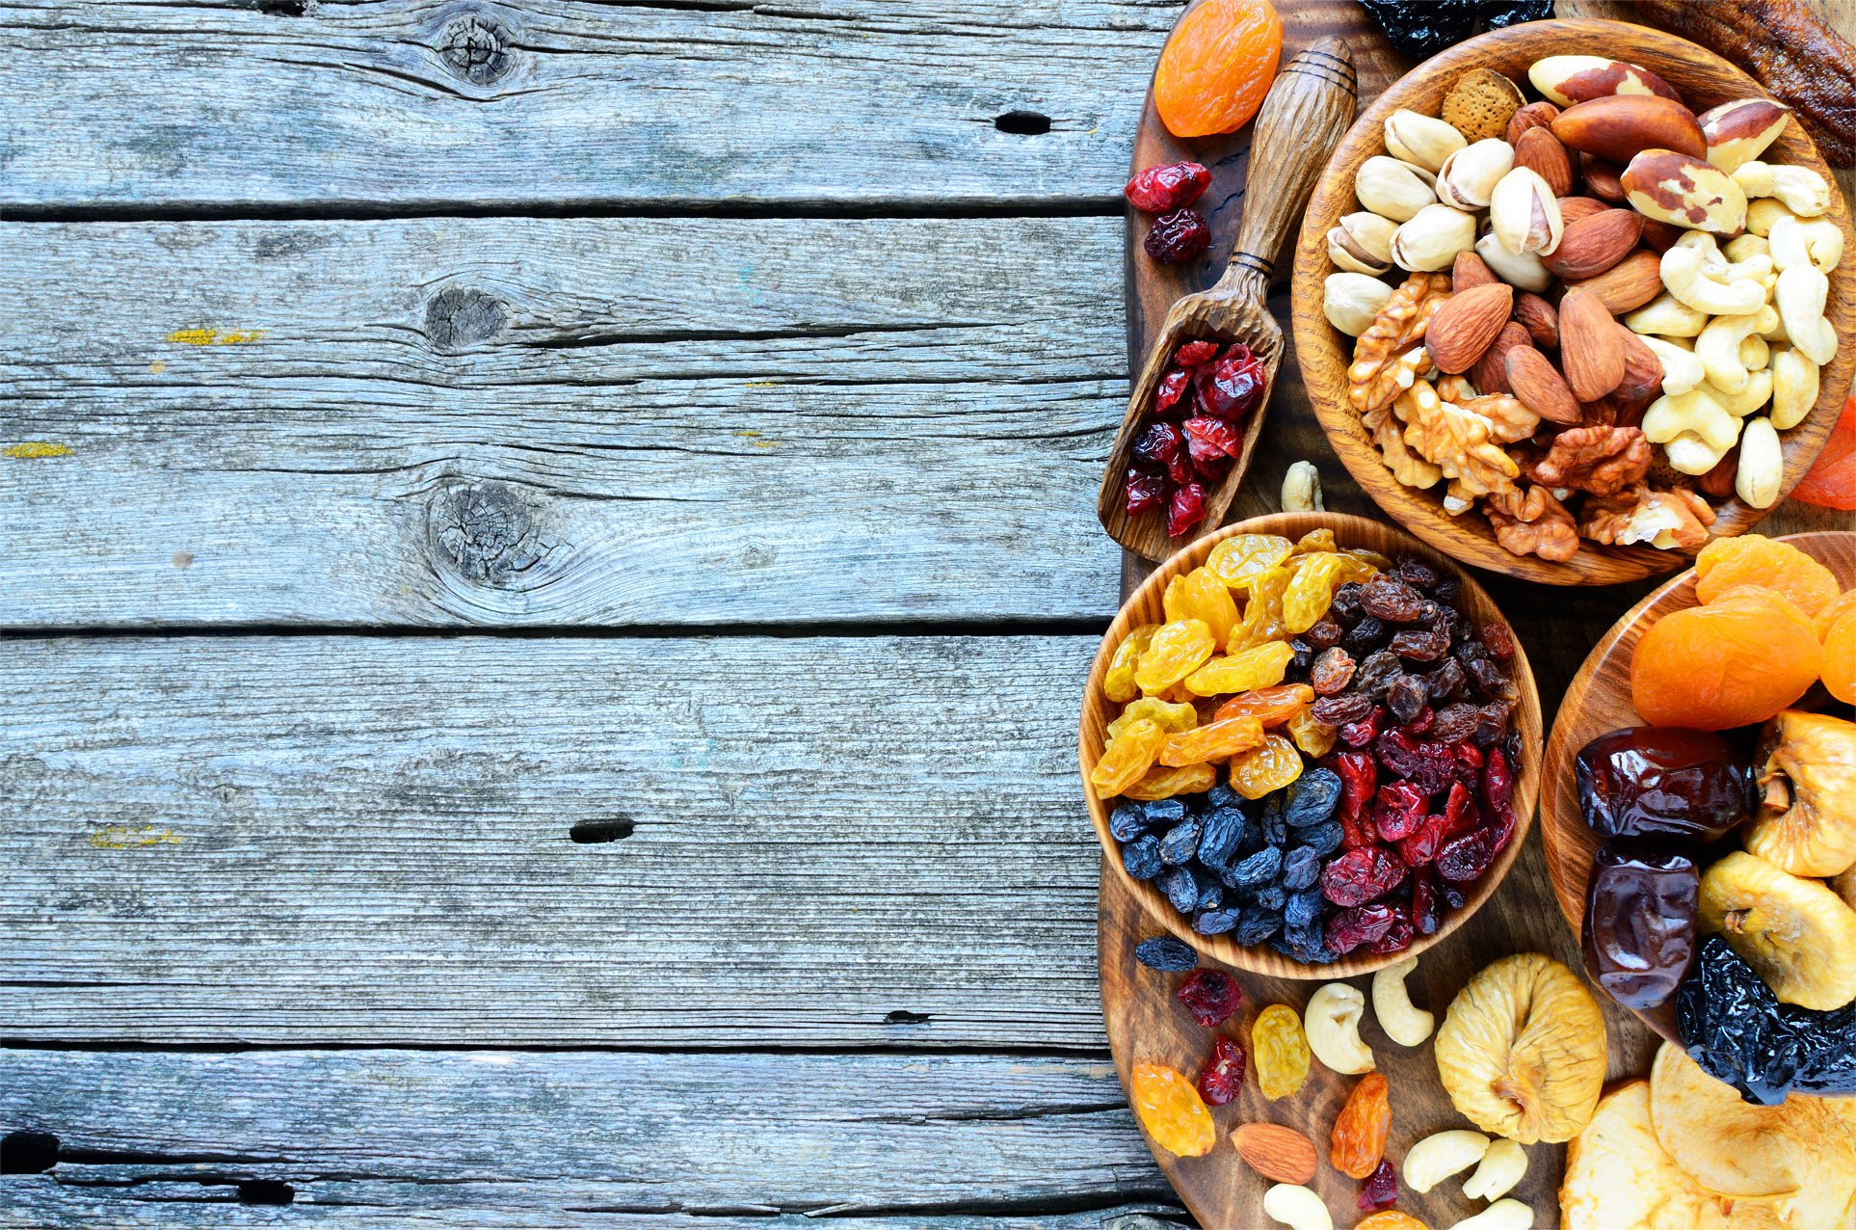

FRUCOM AISBL

RUE DE LA LOI 155

BOX 10, B-1040 BRUSSELS

+32 2 736 79 97

[info@frucom.eu](mailto:info@frucom.eu)